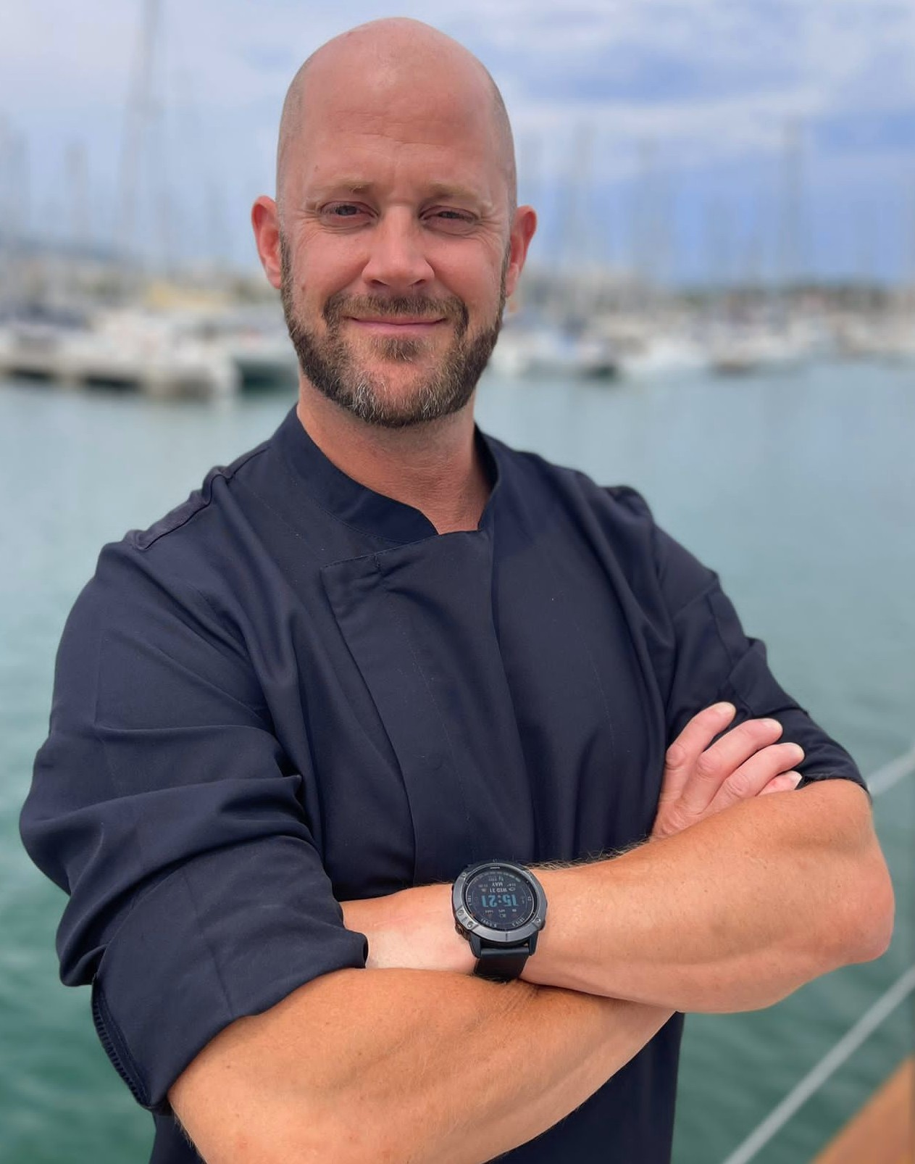**Ian Christopher Sales**

Nationality Scottish

Mobile/WhatsApp +34 603 48 50 42

Licenses and Certification

Ships Cook Certificate

B1/B2 (10 Yrs.)

Professional Cookery Level IV

Food Hygiene 3

Advanced Chocolate & Pastry Course

STCW 10

ENG 1

Powerboat Level 2

PADI Open Water Diver

AST1 Avalanche Safety Training

UK Driver’s License

UK Passport

Native English speaker

Intermediate French

Spanish

Email: [i_mactavish@hotmail.com](mailto:i_mactavish@hotmail.com)

Website [www.chef-iansales.com](http://www.chef-iansales.com)

Personal Profile & Achievements:

I have 18 years high level experience as Head Chef, Sous Chef and in Sole charge roles. Working in a wide range of establishments from Superyachts (4+ Years) to Luxury Lodges.

From Fine Dining Restaurants up to 2 Michelin Star level to Large Event Catering.

Yachting Experience

Hetairos 67m Sailing yacht June 2022 – Nov 2022

Joined the vessel in San Diego before Sailing to the very remote Aleutian Island west of Alaska for a 2 month Owners trip. Provisioning was very challenging as many of the islands were uninhabited and therefore very few places to resupply. We then sailed all the way to New Zealand.

Nov 2021 – May 2022

Several temporary/freelance roles plus 2 months Kitesurfing and traveling in Mexico, Guatemala and Panama.

M5 78m Sailing Yacht, Freelance Head Chef

St Lucia & Med., April - May 2021 + June - Oct 2021

Initially a temporary position covering 2 owner trips. I then re-joined the boat for the Med season. Really interesting and challenging summer working on one of the largest sailing yachts in the world, great Captain and Crew.

The owner changed his mind very often, so flexibility and adaptability were key.

Lionshare 40m Private/Charter Motor yacht

Head Chef, Med/Caribbean, June 2019 – May 2021

Great position working for 2 years with a really good Captain, Owner and Crew.

Based in the Mediterranean for the summers and the Caribbean for the winters.

Always striving to exceed the Owner's and Charter guest’s expectations.

We managed to please even the most demanding of guests.

Africa 47m Private Motor yacht,

Sole Chef, Spain, Croatia, April 2019 - June 2019

This position was meant to be for the whole season however the owners decided they were not going to use the yacht for the summer, so half of the crew were let go to save money.

Ilona 82m Private Motor yacht, Crew Chef

Villanova I la Geltru, Spain, Dec 2018 - Jan 2019

This was a temporary position for 6 weeks covering for a chef on leave. Still a great role to gain experience on larger yachts. Cooking for up to 40 crew and contractors.

Perle Noire 37m Private Motor yacht, Sole Chef

FranceJune 2018 - October 2018

Sole chef on a private yacht cooking for up to 10 guests and 6 crew. Sumer seasonal position, I completed the full season. A great first seasons position to launch my yachting career. Responsible for everything from menu planning to provisioning, washing dishes and detailing the galley.

Land based Work Experience

Boutique Chalet Company – Meribel, France

High End Chalet Company Nov 2022 – April 2023 (current position)

Web <https://theboutiquechalet.com/>

**Chalet Chef**

Cooking high quality breakfast and fine dinning diner for up to 20 Guest and staff in the French Alps.

Gastrologic – Stockholm, Sweden

2 Michelin Star restaurant **, May 2020 – May 2020

Web <https://gastrologik.com/>

**Stage**

I was unable to work for some time on Lionshare during Covid19 due to travel restrictions. So I moved to Sweden and continued my culinary education by doing a stage at this restaurant.

It was a very interesting experience learning about modern Nordic cuisine and cooking at the very highest level.

Ski Talini - St Martin de Bellville, France

Catered Chalet company, Dec 2017 - April 2018

Web [www.skitalini.co.uk](http://www.skitalini.co.uk)

Chalet Chef

Providing high quality breakfast, afternoon tea and 5 course evening meal for 10-12 guest per week.

The Chalet was the sole responsibility of the Chef and Host. Consistently high standards of food, service and cleanliness had to be maintained. The menu and dietary requirements were discussed weekly with the guests.

Caveman Grocer - Whistler, Canada

Paleo Catering Company, Dec 2014 - Sep 2017

Web [www.cavemangrocer.com](http://www.cavemangrocer.com)

Head Chef

This was a relatively new company(5yrs) specialising in pre-made meal home delivery. Although we also catered functions, weddings and weekly farmers markets. During my time with them we doubled the average weekly turnover. My role included developing recipes and creating new menu ideas. Devising the weekly prep schedule. Ensuring it was met and that all meals were delivered on time and prepared to a consistently high standards. In charge of training and motivating a team of 4-5.

Cringletie House Hotel - Scottish Borders

Country House Hotel, Peebles, Scotland, Feb 2014 - Jun 2014

Web [www.cringletie.com](http://www.cringletie.com)

Sous Chef

AA Scottish Hotel of the Year 2013/14 with a 3 Rosettes awarded restaurant.

We ran a daily changing menu as well as a la carte and 6 course tasting menu.

Creative use of the finest local ingredients was very important.

Saké Restaurant - Sydney

Modern Japanese Fine Dining, Sydney, Australia, December 2011 - October 2013

[www.sakerestaurant.com.au](http://www.sakerestaurant.com.au)

Sous Chef

One of the most successful restaurants in Australia. A One Hat restaurant with the Executive Chef making regular guest appearances on Master Chef. I worked the Pass and Pans(mains) Sections. So cooking and plating 150-350 a la carte covers per night!

Guilaumme at Bennelong - Sydney

Fine Dining Restaurant, Sydney Opera House, November 2009 – November 2011

One of the best in Australia, A 3 Hat French(approx. 2 Michelin star equivalent) restaurant situated in Sydney Opera House. Appearing in various Magazines, books and TV shows. I finished on meat section but also ran fish, sauce and garnish sections. This was a very demanding role requiring consistently high standards over very long shifts and service periods(70-75hrs/wk).

Millbrook Resort – Queenstown, 5 Star Golf and Country Club October 2008 – June 2009

Chop Chop Restaurant - Queenstown Western Style Asian Restaurant (Fusion) August 2007 – September 2008

The Horseshoe Inn – Scottish Borders Fine Dining Restaurant, April 2007 - June 2007

Won best restaurant in Scotland

**Hobbies and Interests**

I am very active, a keen Kitesurfer, who regularly practices Yoga and Acro Yoga. I also love Backcountry Snowboarding. I have hiked the whole length of Corsica(220km) and completed a 70km adventure race in Australia. Always keen to learn and try new things!